# INTRODUCTION

Python scripting plays a crucial role in the field of cybersecurity, offering a versatile and powerful toolset for various security tasks. Python's extensive library ecosystem, simplicity, and readability make it an ideal choice for automating repetitive tasks, performing network scanning, vulnerability assessment, and penetration testing. It allows security professionals to develop custom tools and scripts for tasks like log analysis, malware analysis, and forensic analysis. Python's ability to interact with operating system APIs, network protocols, and security frameworks enables the creation of robust and scalable security solutions. Additionally, its integration with popular security tools and frameworks, such as Scapy, Metasploit, and Nmap, further extends its capabilities in areas like packet manipulation, exploit development, and security testing. Python's flexibility and ease of use make it a preferred language for cyber security professionals, enabling them to efficiently address emerging threats and protect systems and networks.

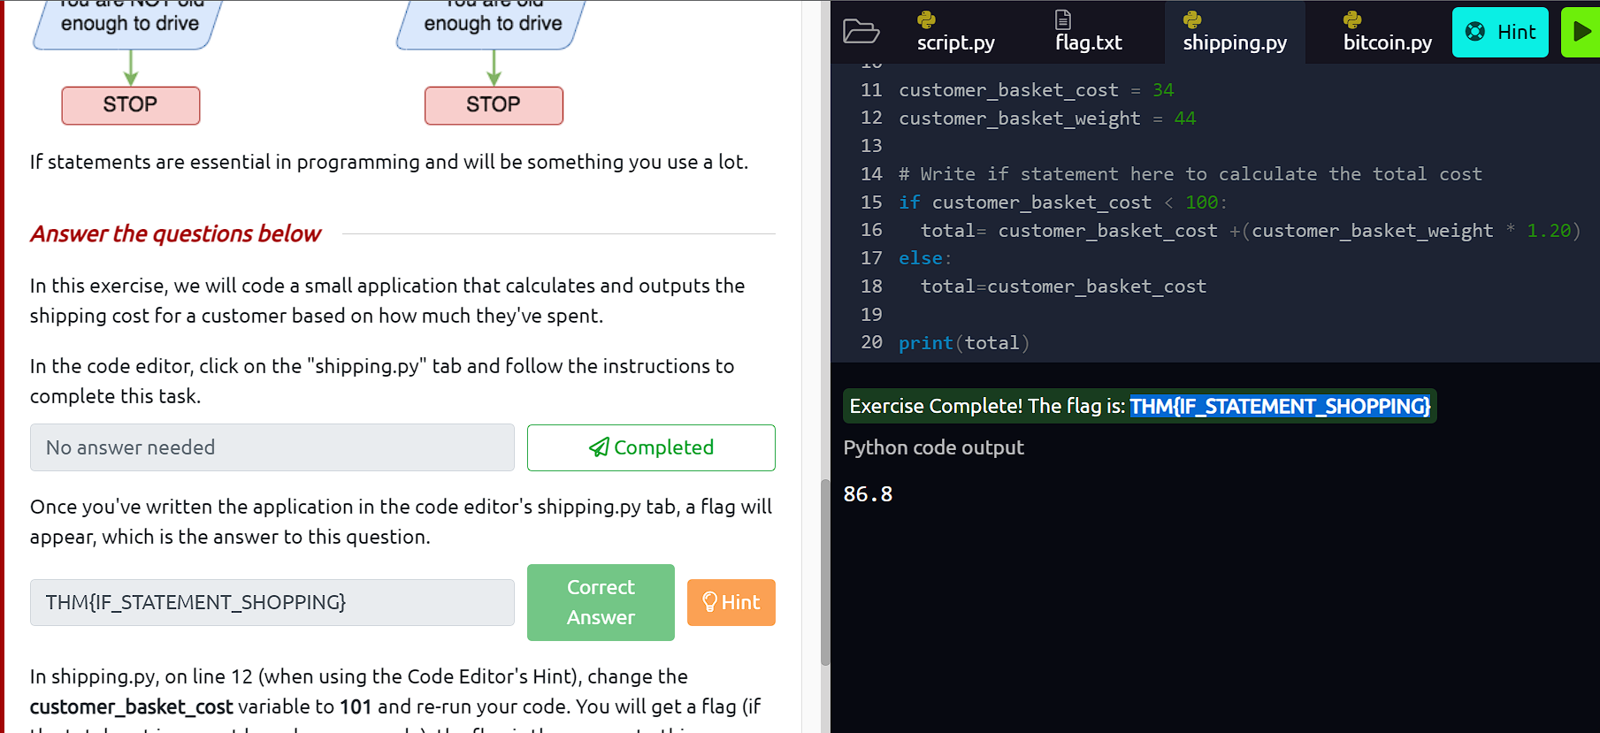

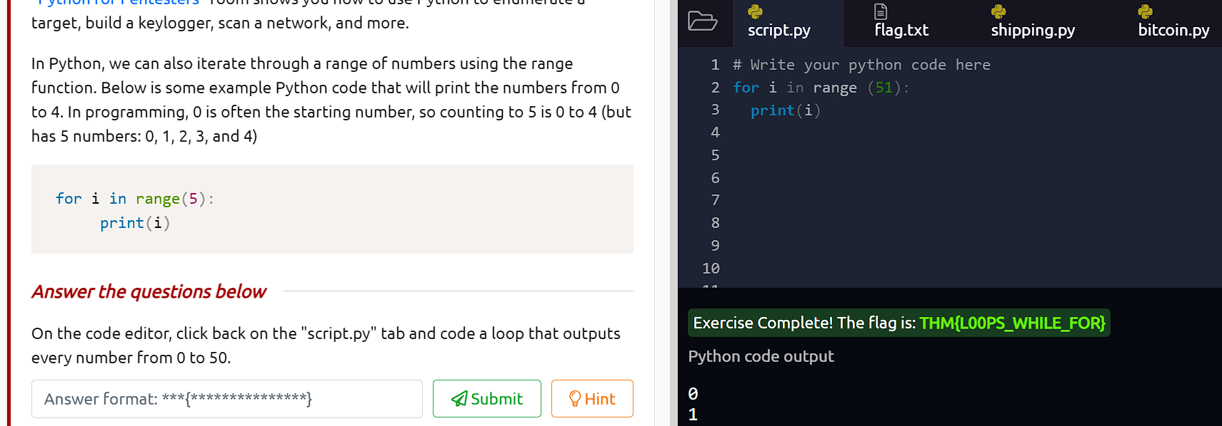

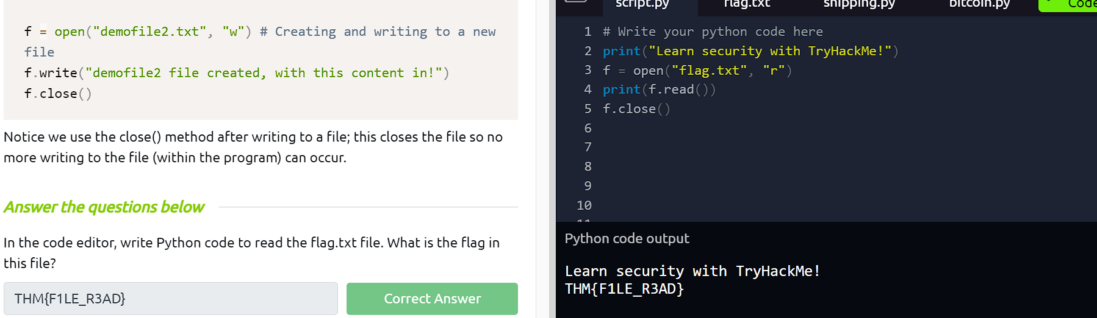



# CONCLUSION

In conclusion, Python scripting is a valuable asset in the realm of cybersecurity, empowering professionals to automate tasks, perform security assessments, and develop custom solutions. Its extensive library ecosystem, ease of use, and integration with various security tools make it a preferred choice for tackling diverse security challenges. With Python, security professionals can streamline processes, enhance efficiency, and stay ahead of evolving threats, ultimately bolstering the protection of systems and networks.